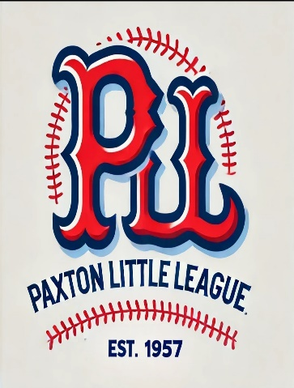
Paxton Little League
Sponsorship
Option 1  Minor League: $250 | - Listing on the Paxton Little League (PLL) website, including your company logo and URL link provided.  - Social media post thanking all sponsors (your business will be listed alongside other sponsors).
Option 2  Major League: $500 | - Choice of:  - Team Co-Sponsorship (your business name on the uniform along with other co-sponsors), OR  - Outfield Signs displayed @ Tivnan Field from March through November.  - Listing on the PLL website, including your company logo and URL link provided.  - End-of-season social media post with your sponsored team’s picture.
Option 3  MVP: $1000 | - Sole Team Sponsorship (your business name exclusively featured on the uniform).  - Listing on the PLL website, including your company logo and URL link provided.  - End-of-season social media post with your sponsored team’s picture.  - Outfield Sign displayed @ Tivnan Field from March through November.  - 2 social media posts per season highlighting your business, sponsor to provide mission statement.
Option 4  Hall of Fame: $1500 | - Team Sponsorship (your business name prominently featured on the uniform).  - Listing on the PLL website, including your company logo and URL link.  - End-of-season social media post with your sponsored team’s picture.  - Outfield Sign displayed @ Tivnan Field from March through November.  - Traveling Team Banner to be displayed at away games.

Contact Name: _______________________________________Company Name: __________________________________________
Phone # _______________________ Email: ___________________________________________________________
Address: ________________________________________________________________________________________
Sponsorship Level Commitment: HOF $2,000____MVP $1000____Major $500____ Minor $250____ Other $_______
Please provide the Level of play you would like to sponsor (Tee Ball, AA, AAA, Majors): Level: __________
*Note: Team sponsorships are awarded as requests are received, limited space available for Jerseys. Please email sponsorships@PaxtonLL.com For best printing, logos for banners need to be vector art (.pdf, .ai, .eps, .svg). For questions, please contact Chris Bousquet at 774-563-1049.

